Comparative analysis of farmer and professional preferences towards conservation agriculture practices in Kendujhar, Odisha; An analytical hierarchy process study
Proposal ID: 587

Abstract:

This study compares farmer and professional mental perceptions, in the village of Tentuli, India, of their preferences of specific conservation agricultural production systems and objectives as they relate to the goal of improved income. The analytical hierarchy process is used to compare mental perceptions of various agricultural technology characteristics. Results reveal that farmers prefer intercrop/ plow with yield, while professionals prefer intercrop/ minimum tillage with profit as the most preferred objective. Results can be used to support and promote collaborations amongst stakeholders and farmers to reduce perception gaps and provide recommendations towards other agricultural efforts in extension, government and agribusiness.

Keywords: Conservation agricultural practices, mental perceptions, analytical hierarchy process, farmers preference

Executive Summary:

Recent research has been focused on the implementation of conservation agricultural production systems (CAPS), with a specific focus on minimum tillage and intercropping, in this area to reduce pressure on natural resources while increasing food security and livelihoods. In this era of increasing agricultural conflict, CAPS represent a new paradigm when facing these challenges. The village of Tentuli within the district of Kendujhar, represents one of the poorest tribal districts in the State of Odisha, India, in terms of both economic and environmental resources. This study compares the farmer and professional mental perceptions of their preferences of specific programs (NO CAPS vs. CAPS) and objectives as they relate to the goal of improved income, highlight the mental perception gaps, and provide recommendations to extension professionals, NGOs, scientists, government and other agribusiness industries looking to explore within the smallholder subsistence farmer (SSF) realm. This study uses the analytical hierarchy process (AHP) as a method to compare mental perceptions of various agricultural technology characteristics by farmers and professionals and thus their preference of selected CAPS. Results reveal that with the goal of improved income, farmers prefer the conservation agricultural program of intercrop and plow with yield as the most preferred objective, while professionals prefer the conservation agricultural program of intercrop minimum tillage with profit as the most preferred objective. Results from this study can be used to support local management and promote collaborations amongst stakeholders and SSFs to reduce perception gaps and provide recommendations for the district of Kendujhar towards other agricultural development efforts in extension, government and agribusiness.

Comparative analysis of farmer and professional preferences towards conservation agriculture practices in Kendujhar, Odisha; An analytical hierarchy process study

Introduction:

Since the Green Revolution, major donor organizations (United States Agency for International Development (USAID), Consultative Group on International Agricultural Research (CGIAR), United Kingdom Department for International Development (DID), Canadian International Development Agency (CIDA), etc.), the NGOs and global foundations supporting the Millennium Development Goals, and the Government of India (Department of Agriculture and Cooperation and Department of Agricultural Research and Education), have allocated millions of dollars in funds and resources to support smallholder subsistence farmers in enhancing productivity and food security. However, it is commonly said that only about 20% of all technology generated in agricultural research is actually adopted by Indian farmers (Chambers 1991; Feder et al. 1985). This figure represents a huge loss to agricultural research for development and the effectiveness of technology transfer mechanisms behind the approaches being promoted to farmers.

Recent research has been focused on the implementation of conservation agricultural production systems (CAPS), with a specific focus on minimum tillage and intercropping, in this area to reduce pressure on natural resources while increasing food security and livelihoods. In this era of increasing agricultural conflict, CAPS represent a new paradigm when facing these challenges. The village of Tentuli within the district of Kendujhar, represents one of the poorest tribal districts in the State of Odisha, India, in terms of both economic and environmental resources. It was selected by the in-country project partner, Orissa, University of Agricultural Technology (OUAT), based on its existing relationship with OUAT and exhibiting suitable village characteristics suited for on-farm trails of selected conservation agriculture practices. The village consists of a small population of smallholder subsistence farmers (SSF) that grow on land that suffers from poor soil fertility, poor moisture retention, limited irrigation, susceptibility to erosion, and other external pressures of development and environmental conflicts of climate change (SMARTS 2009). Although these programs offer a positive and sustainable outcome to these farmers, given the statistics, why do these farmers not adopt?

Limited studies have actually analyzed why farmers do not adopt (Bentley 1994; Chambers 1988; Rhoades and Booth 1982). Historical perspectives exploring this issue reveal a timeline of events that expose the potential for a new paradigm for farmer participation that needs to be explored (Carr and Wilkinson 2005; Eshuis and Stuiver 2005). In the 1950/60s, agricultural support in developing countries consisted of a one-way scope in which extension professionals, scientists and social scientists assumed that the technology was good and that farmers were ignorant if they chose not to adopt (Chambers 1991). In the 1970/80s, there was a realization that there were farm-level constraints to adoption and attempts were made to make the farm like the experimental research plots (to make A fit C) (Chambers 1991). In the 1990s, these same groups still could not understand the lack of adoption by farmers and developed various approaches that incorporated farmers into the technology developmental process, such as the farmer participatory research (FPR) and transfer-of-technology (TOT) approach, in which they brought the research out of the lab and developed it on the farm transferring packages of information developed to farmers (Carr and Wilkinson 2005; Chambers 1988; Eshuis and Stuiver 2005; Knowler and Bradshaw 2007). It is not until today that these same groups are beginning to realize that these approaches are not meeting original expectations. A recent study by Knowles and Bradshaw (2007) assimilated disparate research efforts around the world to better understand the farm-level adoption of conservation agriculture; however, results revealed that although information may be the key factor to adoption, the study indicates it is also location specific. Therefore, the concept of adoption may not only be how the technology is generated but who the information is generated from and how it is disseminated to the farmer.

For this reason, this study focuses on analyzing the potential knowledge systems of the farmers compared to professionals in the field as they are seen as different. Professionals are trained to be analytical and apply a systematic scientific method, whereas farmers are looking for what works depending on a dynamic environment (Carr and Wilkinson 2005). As the farmer is the key locus of decision making when it comes to adoption, it is important that their mind set and indigenous knowledge is in line and incorporated with that of the scientists’ plans and programs.

Objectives:

It is now recognized that typical on-farm participatory research such, as transfer of technology approaches (professionals take the lead in developing technology at the research station with minimal farmer input), will not overcome all the barriers that professionals and farmers face in terms of adoption against the timeline of environmental degradation and food insecurity. Farmers need these appropriate and effective technologies (i.e. CAPS) to improve their livelihood and have the indigenous and cultural knowledge necessary to help develop the necessary economic and ecological frameworks, while professionals have the resources and education to make them effective and sustainable. As such, it must be recognized that different sources of knowledge are all valuable as each may have access to different experiences (education, social and economic opportunities) but must be appreciated in order to achieve maximum benefits (Carr and Wilkinson 2005; Knowler and Bradshaw 2007). Thus, the objective of this study is to compare the farmer and professional mental perceptions of their preferences of specific programs (NO CAPS vs. CAPS) and objectives as they relate to the goal of improved income, highlight the mental perception gaps, and provide recommendations to extension professionals, NGOs, scientists, government and other agribusiness industries looking to explore within the SSF realm. Each group (i.e. farmers, development expert scientists and extension specialists) has a different pool of valued knowledge, as mentioned previously, that must be considered for maximum benefits and potential for adoption.

This study uses the analytical hierarchy process (AHP) as a method to compare mental perceptions of various agricultural technology characteristics by farmers and professionals and thus their preference of selected CAPS. AHP is preferred over other methodologies since farmers’ preference of farming practices and technologies cannot be explained by a single objective but by a trade-off between multiple objectives to achieve their goal when given a number of choice options.

Procedures:

The methodological framework of this study consists of three main steps (Parts A-C):

- Developing the Preference Survey
CAPS are a recent innovative system approach to farming practices that utilizes local resources and expert advice to ensure sustainable productivity while maintaining a healthy soil environment. In this study, three maize-based CAPs (varying no-till and minimum till practices and intercropping with cowpea) and control (no-till) treatments were chosen as the feasible array of technologies and practices to be examined (Table 1). One or more of these treatments will be adopted for eventual implementation in the village of Tentuli. Specifically, the three treatments were selected based on the assimilation of agronomic data accumulated from experimental plots and site visits, and socio-economic results from a household baseline survey administered to farmer head of households and focus groups in June 2010 (Table 1).

The three conservation agriculture practices include one or more of the following:

1. Minimum tillage (MT): Land was tilled once prior to sowing vs. conventional tillage (CT) where land is tilled twice.
2. Intercropping (M-CP): Cowpea (Vigna unguiculata) was planted between rows of maize (Zea mays). The inter-row spacing for maize was standard for a maize monocrop treatment (M), with no reduction of maize plants in the intercropped treatment.

Table 1: Conservation Agriculture (CA) programs implemented in Kendujhar, Odisha State, India, 2010.
Interventions | CA Practices (Abbreviations)
Farmer Practice: Maize Plow | NO CAPS
Maize Minimum Tillage¹ | CAPS 1
Maize/Cowpea Intercrop Plow² | CAPS 2
Maize/Cowpea Intercrop Minimum Tillage² | CAPS 3
Source: Household Survey Data 2010
¹For maize only plot size 0.005 ha
²For maize/cowpea intercrop plot size is 0.045 ha for maize and 0.045 ha for cowpea (original plot size, 0.005 ha, divided in half)

The Analytical Hierarchy Process, developed by Thomas Saaty (1980) was used to explore farmers’ and professionals’ preferences of the various CAPS and the criteria/objectives the farmers used to make the decisions (Part B). AHP breaks down decision making into an easy to understand hierarchy of priorities that reflect an optimal goal, objectives and various choice options. Therefore, in order to understand the mental perceptions for both the professionals and farmer’s group, the study uses the results from the AHP method to highlight information gaps (i.e. different priorities for objectives and thus different preferences).

A subsequent study in 2010/2011 was developed comparing the technological outcomes of these three CAPs to a control treatment (baseline representative farm system from the analysis of the farmer household surveys) based on four criteria (profit, yield, labor saving, and soil environmental benefit) that were recognized as directly related to maximizing farmers’ income. The four criteria were selected based on previously assimilated information (Lai et al. 2011), literature review, and focus group discussions.

Table 2: Comparative analysis of the four selected objectives, NO CAPS vs. CAPS, Lai et al. 2011.
Programs | Profit | Labor Saving | Yield | Environmental Benefit
NO CAPS  Maize Plow | + | ++ | +++ | 0
CAPS 1  Maize Minimum Tillage | 0 | +++ | 0 | ++
CAPS 2  Maize/Cowpea Intercrop Plow | +++ | + | ++++ | +
CAPS 3  Maize/Cowpea  Minimum Tillage | ++ | 0 | +++ | +++
Determined based on 2010 KVK research station experimental farm plots

  - Applying the Analytical Hierarchy Process (AHP)
The CAPS treatment preferences using AHP is desirable because it breaks down individual perception and weighs the multi-decision criteria for choosing certain treatment options. AHP was developed by Thomas Saaty (1980) in which the method is well known for its ability to break down decision making processes into an easy to understand hierarchy of priorities that reflect an optimal goal, objectives and various choice options (programs) (Braunschweig 2000; Dyer and Forman 1992). It was selected over other methodologies for this study as choosing a preference of farming practices and technologies is multifaceted and cannot be explained by a single objective. Rather, the decision making process includes a compromise between multiple objectives to achieve the ultimate goal when given a number of decision options.

Creating the appropriate “Farmers/Professional Preference” AHP for decision-making (Braunschweig 2000):
- Developing the hierarchy (beginning from the top), Figure 1:
  - Determine the ultimate goal of the decision (Level 1: improved income)
  - Determine the decision objectives on which the following program decisions depend (Level 2: profit, labor saving, yield, and soil environmental benefit (Lai et al. 2011), and
  - Provide the selected choice programs at the lowest level (Level 3: Control, CAPS 1, CAPS 2, CAPS 3)

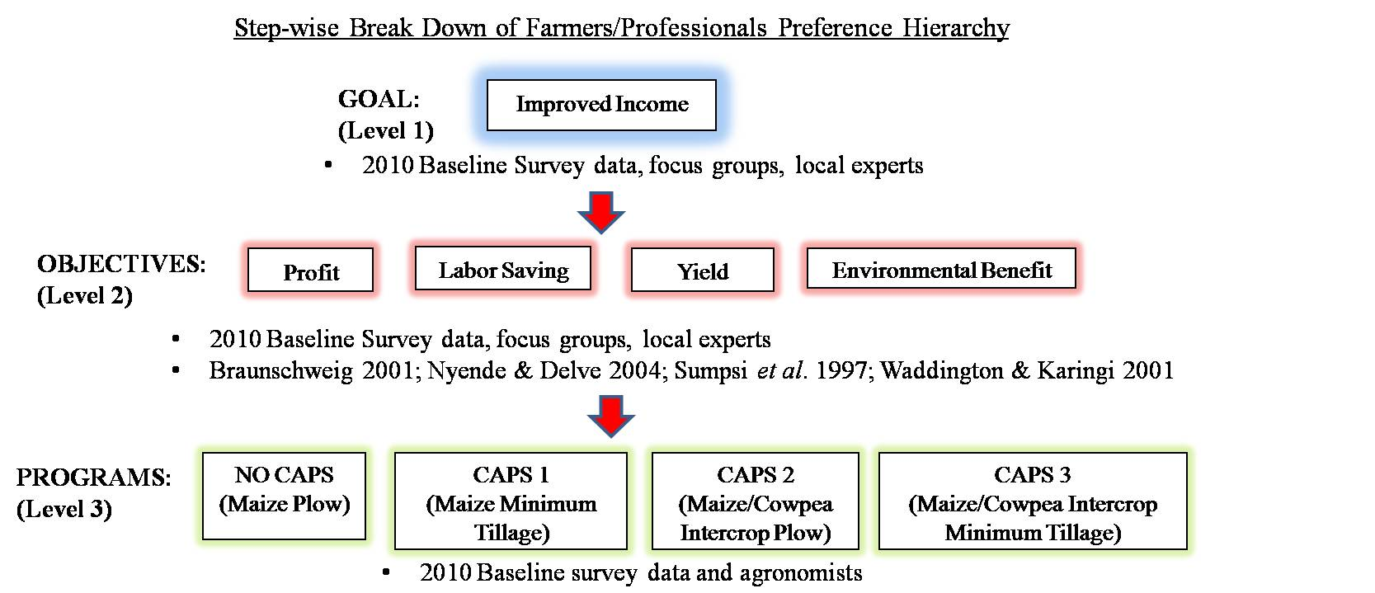
Figure 1: The step-wise breakdown of farmers/professionals preference of the four programs as it relates to the three levels of AHP (with subsequent references and sources of data), AHP survey 2011.

- Evaluate the programs and weigh the objectives. This may be completed by developing pairwise comparison matrices for each level of the hierarchy, Figure 2 (Braunschweig 2000; Saaty 1980).

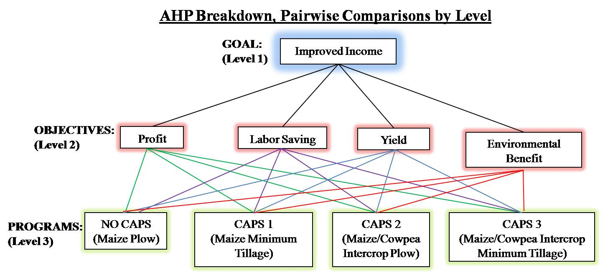
Figure 2: The preference AHP decision-making break down displaying pairwise comparisons indicated by the adjoining lines of each level: Goal, Objectives, and Programs of the hierarchy, AHP survey 2011.

The programs are compared in pairs to determine their relative importance with respect to each objective. Similarly, the objectives are compared in pairs to determine their importance with respect to the ultimate goal.

Each set of comparative judgments is organized into an individual matrix to determine the “local” priority or significance (weight) for that level of the hierarchy; for example, the preference of the programs with respect to a specific objective. Figure 3 displays the matrix to input the pairwise comparisons.

A= $\left[\begin{matrix}a11 & a12 & a1n \\ a21 & a22 & a2n \\ ⋮ & ⋮ & ⋮ \\ an1 & an2 & ann\end{matrix}\right]$ where aij = 1/aji for all i,j = 1, 2, … , n
Figure 3: Matrix to develop local priorities. The diagonal cells such as a₁₁, a₂₂, a₃₃, etc. always contain the value 1.

In order to determine the weight factors of the objectives and evaluate the programs based on non-quantifiable objectives, the use of verbal comparisons was implemented to determine relative importance (Table 2). These verbal comparisons are then translated into numerical values following this scale set:

S = $\left\{\frac{1}{5}, \frac{1}{4},\frac{1}{3},\frac{1}{2},1,2,3,4,5\right\}$

For example, using Table 2 and inputting into Figure 3, if program 1 is strongly favored over program 2, then a₁₂ would be given a score of 5. If the opposite held, that program 2 was strongly favored over program 1, then a₁₂ would be given the reciprocal score of 1/5.

Table 2: The 5-point scale for pairwise comparisons of importance, AHP survey 2011
Importance | Verbal Title | Explanation
1 | Equal | Two elements are seen as identical in preference
2 | Moderate | One element is slightly favored over the other
3 | Strong | One element is strongly favored over the other
4 | Very Strong | An element's dominance is apparent in practice
5 | Extreme | An element’s preference is completely dominant over the other

- Synthesize the local priorities throughout the hierarchy (each subsequent level from Level 1), in order to compute the global priorities of the programs. (Braunschweig 2000; Saaty 1980)

P_{l}$= \sum_{M=1}^{M}{p}$_{lm}v_{m} with $\sum_{l=1}^{L}{p}$_{lm} = 1 and $\sum_{m=1}^{M}{v}$_{m} = 1

Where:
P_{l} = final priority of Program l
P_{lm} = priority of program l with respect to criterion m
V_{m} = weight of objective m
l = program (1… L); for this study: NO CAPS, CAPS 1, CAPS 2, CAPS 3
m = objective (1… M); for this study: Profit, Labor Saving, Yield, and Environmental Benefit

The Braunschweig equations illustrate that for each program, the local priorities are multiplied by the corresponding objective weight, and the results are summed up to obtain the global priority of the project with respect to the ultimate goal.

The consistency index (C.I.), as a deviation or degree of consistency is computed for the farmer and scientist participants and it may be determined by the following formula:

C.I. = (λ_{max} – n)/ (n – 1)

Using the Random Consistency Index (R.I.), developed by Saaty, the appropriate Consistency ratio (C.R.) may be determined:

C.R. = C.I./R.I.

A C.R. value of 0.1 is acceptable, but larger values represent inconsistent results and the decision maker must reduce this by re-evaluating preferences.

- Administering the Preference Survey

Given the above decision matrix and methodology, the decision problem considered in this study was how to determine what the best alternative program (NO CAPS vs. CAPS), given the selected objectives, with the ultimate goal of improved income. For this study, an occupational definition of farmers and professionals was used. Therefore, farmers were defined as people who work on and manage farms on a daily basis. Professionals were defined as people working in scientific and/or technical positions in either the private or public sector in agriculture.

Due to the varying levels of literacy of the farmers compared to the professionals, information sharing and survey administration during this workshop was delivered through multiple communicative techniques including posters, handouts, PowerPoint slides, and the use of trained local translators.

The survey consisted of a total of 5 pages and 6 questions on each page. For the survey, participants were asked to: a) “State which objective/program was more important/preferred”; and b) “Show the level of ‘importance’” compared to other objectives/program using a verbal scale. In two separate survey sessions (farmers and professionals), two leading socioeconomic researchers facilitated the administering of the survey.

- The Farmers
Three weeks prior to the preference workshop, multiple announcements were made to invite farmer head of households at internal village meetings to participate in the workshop. Based on complete voluntary cooperation and incentives to participate, such as free transport from the village to the research station and a complimentary lunch on workshop days, ten male and eight female farmer head of households from the village of Tentuli out of 56 households participated in the survey. In order to reduce potential misinterpretation of materials/questions and minimize survey response error, each participating farmer was paired with a trained recorder when completing the survey.

- The Professionals
Similar to the farmers, three weeks prior to the workshop, professionals from various nearby agricultural institutions and organizations were invited by the Dean of the College of Agriculture at Orissa University of Agriculture and Technology and the host country scientist at the research station to participate in the workshop.

C. Comparative analysis of farmers and professionals preferences
For the purposes of this study, the Expert Choice software (version 11.5.829) “Pairwise Verbal Comparisons” approach was used to conduct the survey, input and analyze the data. The pairwise verbal comparison approach, offered by Expert Choice, followed the 5-point scale for pairwise comparisons of importance. For the farmers, representation of their selected responses (importance) was indicated to the recorder by the number of candies (1-5) provided.

Results:

The data for this study was collected during an interactive workshop in March of 2011 titled, “Sustainable Management of Agroecological Resources for Tribal Societies”. Using Expert Choice software, data of the survey was inputted and results of the AHP survey were synthesized.

- The Farmers

The following table represents farmers’ preference (weights) of each of the four objectives with respect to each program (NO CAPS vs. CAPS). These weight factors provide a measure of the relative importance of the programs by objectives for the farmer (See Table 3).

Table 3: Synthesis of overall farmers’ preference (weight) represented for each alternative program with respect to each objective, AHP survey data 2011.
Program | Profit | Labor Saving | Yield | Soil Environmental Benefit
NO CAPS | 0.101 | 0.219 | 0.142 | 0.084
CAPS 1 | 0.089 | 0.233 | 0.080 | 0.208
CAPS 2 | 0.412 | 0.285 | 0.504 | 0.201
CAPS 3 | 0.398 | 0.263 | 0.274 | 0.507

Synthesis of these results revealed that, with respect to the goal of improved income, farmers’ preferences of the four objectives were, in order of the highest to the lowest: yield followed closely by profit, soil environmental benefit and labor saving (Figure 4). The inconsistency ratio is less than 10%, thus the inconsistency is acceptable and the farmers’ evaluation of her/his objective preference is consistent.

Figure 4: Synthesized results of farmers’ preference of objectives with respect to improved income. Yield represents the most preferred objective (Expert Choice, AHP survey data 2011).

Next, Figure 5 represents the synthesized normalized results of the AHP survey revealing that, with respect to the goal of improved income as it relates to the four CAPS programs, farmers preferences ranked the highest for CAPS 2 of maize/cowpea intercrop with conventional plowing. This was closely followed by the second highest preferred program, CAPS 3, of maize/cowpea intercrop minimum tillage. The inconsistency ratio for this result is less than 0.1, thus the inconsistency is acceptable and the farmers’ evaluation of her/his program preference is also consistent.

Figure 5: Synthesized results of farmers’ preference in production systems with respect to the goal of improved income. CAPS 2 represents the most preferred program (Expert Choice, AHP survey data 2011).

- The Professionals

The following table represents professionals’ preference (weights) of each of the four objectives with respect to each program (NO CAPS vs. CAPS). These weight factors provide a measure of the relative importance of the programs by objectives for the professionals (See Table 3).

Table 3: Synthesis of overall professionals’ preference (weight) represented for each alternative program with respect to each objective, AHP survey data 2011.
Program | Profit | Labor Saving | Yield | Environmental Benefit
NO CAPS | 0.063 | 0.191 | 0.116 | 0.063
CAPS 1 | 0.134 | 0.307 | 0.099 | 0.214
CAPS 2 | 0.244 | 0.186 | 0.380 | 0.145
CAPS 3 | 0.558 | 0.316 | 0.404 | 0.578

Synthesis of these results revealed that, with respect to the goal of improved income, professionals’ preferences of the four objectives were, in order of the highest to the lowest: profit followed by environmental benefit, yield and labor saving (Figure 6). The inconsistency ratio is less than 10%, thus the inconsistency is acceptable and the professionals’ evaluation of her/his objective preference is consistent.

Figure 6: Synthesized results of professionals’ preference in production systems with respect to the goal of improved income. Profit represents the most preferred objective. (Expert Choice, AHP survey data 2011)

Last, Figure 7 represents the synthesized normalized results of the AHP survey revealing that, with respect to the goal of improved income as it relates to the four programs, professionals’ preferences ranked the highest for CAPS 3 of maize/cowpea intercrop with minimum tillage plowing. This was followed by the second highest preferred program, CAPS 2, of maize/cowpea intercrop plow. The inconsistency ratio for this result is less than 10%, thus the inconsistency is acceptable and the professionals’ evaluation of her/his program preference is also consistent.

Figure 7: Synthesized results of professionals’ preference in production systems with respect to the goal of improved income. CAPS 3 represents the most preferred program (Expert Choice, AHP survey data 2011).

Discussion:

The overarching results of this analysis shows that there exist mental perception differences between the farmers and professionals in terms of CAPS and their preferred objectives and as such, may lead to future problems when it comes to final adoption.

The results obtained from this study corroborate with previous findings found in the dearth of literature that support farmers’ preference of yield being a significant criteria for farmer practices and technologies in developing countries (Nyende and Delve 2004; Snapp et al. 2003). By contrary, professionals selected profit as the preferred priority as it relates to the goal of improved income. Due to their background as professionals with a consistent monetary income, it is apparent their thought process would equate improved income to cash resources and subsequently wealth accumulation.

As logic is locally contingent and socially produced, professionals are not aware of the additional benefits that farmers see regarding greater yields that may lead to improved income. To be specific, farmers are more preoccupied producing the highest crop yield for their own consumption and producing enough marketable surplus yields to sell to the local and town market. Ultimately, with small plot sizes (<2 ha) farmers are aiming to achieve maximum plot efficiency (produce the most yield on the limited land that they have). Furthermore, according to focus group discussions and household survey interviews, the barter system still exists within the village. As such, some farmers with surplus yield in storage may trade specific crops such as maize or rice for other household kitchen items such as cooking oil or salt (more expensive in the market, leading to minimal but increased income savings) (Lai et al. 2011).

In this study, professionals only see profit as directly related to generated income. An additional consideration in this study, comparing farmer and scientific preferences and knowledge, is that farmers may also have separate definitions for profit depending on the topic at hand. In Tentuli, farmers may earn income outside of the farm through off-farm employment in local iron ore mines. Families in Tentuli with more than one male over the age of 18 may send one male to the mines to earn additional income if necessary to support the family. Therefore, when it comes to agricultural criteria specifically towards the goal of improved income, yield is seen as profit. While the cash value that professionals see as profit in this case, farmers see as secondary to agriculture yield (as farmers may resort to off-farm employment at the mines for any additional income).

It is interesting to note that professionals chose environmental benefit over yield in terms of criterion for improved income. It is clear that with their professional background that environmental benefit would be a high priority for sustained income; however, this result proves that there is clearly a mental perception gap that exists between professionals and farmers in terms of improved income as it relates to agriculture.

Even with minimal to no environmental education and experience with CAPS, farmers ranked the environmental benefits over labor saving with respect to achieving improved income. This may be a result of the 2011 March SMARTS workshop that emphasized the environmental benefits of CAPS, specifically soil environmental benefits (Lai et al. 2011). In their poorly controlled and unfavorable agricultural environment of Tentuli, farmers may already be aware of the degrading environmental conditions (i.e. increased soil erosion, drought, etc.) that are becoming enhanced due to climate change and other pressures. Therefore, this workshop may have increased their awareness of environmental issues and solutions.

In terms of labor, since typical plot sizes are relatively small, the majority of the plots can be managed and accounted for by two adults (head of household and wife) and if needed, the children, (2010 baseline survey data) making this objective not as significant compared to others for both professionals and farmers.

Subsequently, for farmers, it is clear their choice in CAPS programs would relate directly to that which resulted in the greatest yield and profit (CAPS 2 followed by CAPS 3) as their preferred program for improved income. In addition, farmers did not see the labor saving characteristics of CAPS 2 and 3 compared to the control (Table 1) as a drawback at all; to them, the trade-off of higher yields and income was more important. For professionals, based on their preferences of objectives (profit followed by environmental benefit), their preference for programs was CAPS 3. Unlike the farmers, professionals were very clear in their selection for CAPS 3 (a weight of almost twice that of CAPS 2 and others). As such, it is apparent the significance of environmental benefit as a preferred objective for professionals.

The results within this study clearly point out the mental perception gap that exists between the farmers and professionals. Nonetheless, it is clear that both farmers and professionals are certain in what they want and see as important. In this study, there were very minimal inconsistencies (<0.05). For the farmers (inconsistency <0.02), they were very strong in their decisions selecting yield and profit and subsequently the programs that provided those objectives; while the professionals had a slightly higher (although minimal, <0.05) inconsistency. This higher inconsistency may be due perhaps to their more analytical backgrounds requiring greater thought in trade-offs amongst the objectives and programs.

Conclusions:

This study reveals the fundamental perception gap between the farmers and the professionals in technology transfer, specifically, the incompatibility of priorities. If scientists and farmers are working together, they must be trying to achieve the same goal together; however, with different perceptions, logic and background, this becomes more complex. A study by Eshuis and Stuiver (2005) termed the two mental perceptions as “farmer knowledge” and “scientific knowledge” where scientific knowledge in on-farm research is categorized as “average quality” because it results in sub-optimal results and farmers’ knowledge as “practical knowledge”, or “workable knowledge”, as it is the more relevant and appropriate for the circumstances. A partnership for conducting on-farm research, where farmers participate in setting experimental objectives and defining standards for technology and agricultural management can qualitatively improve researchers’ concepts of how to evaluate, improve and adapt technology, and subsequently enhance farmer adoption. Professionals must understand a new reality that professionals and scientist often perceive technical problems and ideas through different eyes than farmers: losses to professionals are not necessarily losses to farmers. Based on these study results, professionals should reevaluate current programs (technologies) to include high yielding varieties and minimum tillage in order to achieve results that satisfy farmers’ and professionals’ objectives of enhancing food security, income and the environment.

While farmers are constantly reacting and acting in a dynamic and changing environments, they are learning by adapting. This and previous studies are beginning to reveal the existence of mental perception gaps between farmers and professionals, and ultimately stakeholders. In the period of environmental change and economic progress, there is great significance in reducing these perception gaps and overlapping knowledge systems to achieve optimal agricultural results and more broadly resource efficiency and sustainability (Figure 8).

Table 4: Potential role of stakeholders in reducing the perception gap and subsequently enhancing the livelihood and food security of smallholder subsistence farmers in the District of Kendujhar, Odisha State, India.
Stakeholder Group | Role (Objective)
Farmers | - Collaborate with extension research and agribusiness stakeholders  - Practice autonomous decision making and actively participate in setting experimental objectives and defining standards for technology and agricultural management  - Communicate knowledge of useful technologies from one farmer to another
Extension Research (professionals, scientists, etc.) | - Obtain information from farmers’ behaviors and redirect decision making to provide farmers with information to enable them to make their own analyses and decisions (set experimental objectives define standards for crop management)  - Reevaluate current technologies to incorporate farmers priorities and “practical knowledge” alongside “scientific knowledge”  - Example Approach: First-First-And-Last (FFL) model, begins with a systematic process of scientists learning from, and understanding, SSF families, their resources, needs and problems to then incorporate conservation agriculture technologies  (Carr and Wilkison, 2005; Feder et al. 1985)
Agribusiness | - Develop good relationships to collaborate with extension research and link with groups of SSFs  - Support SSFs through technical assistance, training, small grants to invest in infrastructure, and loans to purchase inputs  - Provide services such as market information, intelligence and promotion  - Example Approach: Core-Satellite Model, private sector (core) food processors or seed producers partner with groups of SSFs (satellites) through production contracts and exchanging agricultural inputs and services for assured deliveries of produce (Kirsten and Sartorius 2002;Goldsmith 1985)
Government  (policy, decision-makers) | - Promote the partnership of SSFs to work with extension research and agribusiness to encourage sustainable development and progress  - Provide improved access to credit and loans  - Introduce/promote programs to encourage the adoption of conservation practices, specifically minimum (conservation) tillage  - Example Approach: State subsidy program (seeds, inputs, technology)  (Kirsten and Sartorius 2002; Lutz1998 )

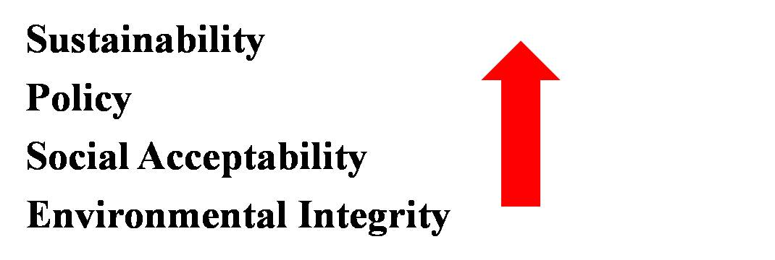
Figure 8: Investments into physical and human capital to improve resource efficiency and enhance the livelihood of SSF and progress in developing countries (Scheele 2011)

Extension researchers and development agencies are reaching out to agribusiness for assistance and agribusiness are looking at policy to implement the necessary changes to instill progress for developing countries. Decision makers can make the choice of taking a hands-off role in which the process will be a lot slower in achieving sustainable agriculture benefits due to farmer constraints (land availability, credit, access to markets), or take an active role and implement supporting policy or subsidies to aid in production to speed up the process. Although this process may require more time as it is new and not widely accepted, especially in developing countries where other social and environmental conflicts may be of priority, these investments can lead to improved resource efficiency and ultimately, sustainability (Figure 8).

There is value behind different sources of knowledge and SSFs need alternative styles of generating new and more effective technology. However, this cannot be successfully done or the perception gaps reduced unless each group has the applicable knowledge necessary to instigate adoption; as such, the main locus of research and learning should be the SSF. As stated by Forester (1999), “learning occurs not just through arguments, not through the reframing of ideas, not just through the critique of expert knowledge, but through transformation of relationships and responsibilities, of networks… and membership” (Forester 1999). This study can be used to support local management and promote collaborations amongst stakeholders and SSFs to reduce perception gaps and provide recommendations for the district of Kendujhar towards other agricultural development efforts in extension, government and agribusiness.

- References

Bentley, J. 1994. Facts, fantasies, and failures of farmer participatory research. Agriculture and Human Values. 11, 140-150

Braunschweig, T. 2000. Priority setting in agricultural biotechnology research: supporting public decisions in developing countries with the analytic hierarchy process. ISNAR Research Report. 16, 1-110.

Carr, A. and R. Wilkinson.2005. Beyond participation: boundary organizations as a new space for farmers and scientists to interact. Society and Natural Resources. 18, 255-265.

Chambers, R. 1988. Farmer first. International agricultural development. 8, 10-12.

Chambers, R. 1991. Scientists or resource-poor farmer- whose knowledge counts? Seminar on Crop Protection for Resource-Poor Farmers, Sussex, United Kingdom. 1-7.

Dyer, R. and E. Forman. 1992. Group decision support with the analytic hierarchy process. Decision Support Systems. 8, 99-124.

Eshuis, J. and M. Stuiver. 2005. Learning in context through conflict and alignment: farmers and scientists in search of sustainable agriculture. Agriculture and Human Values. 22, 137-148.

Feder, G., Just, R. and D. Zilberman. 1985. Adoption of agricultural innovations in developing countries: a survey. Economic Development and Cultural change. 33, 255-298.

Forester, J. 1999. The deliberative practitioner: encouraging participatory planning processes. Cambridge, Massachusetts: The MIT Press.

Goldsmith, A. 1985. The private sector and rural development: can agribusiness help the small farmer? World Development. 13, 1125-1138.

Kirsten, J. and K. Sartorius. 2002. Linking agribusiness and small-scale farmers in developing countries: is there a new role for contract farming? Development Southern Africa. 19, 503-529.

Knowler, D. and B. Bradshaw. 2007. Farmers’ adoption of conservation agriculture: A review and synthesis of recent research. Food Policy. 32, 25-48.

Lai, C., Chan-Halbrendt, C., Halbrendt, J., et al. 2011. Comparative Economic Analysis of Conservation Agricultural Practices in Tribal Villages in India. Unpublished Study

Lai, C., Chan-Halbrendt, C., Halbrendt, J., et al. 2011. Farmers preference of conservation agricultural practices in Kendujhar, Odisha: using the analytical hierarchy process. Unpublished Study

Lutz, E.1998. Agriculture and the environment: perspectives on sustainable rural development. Washington, D.C.:World Bank Publications

Nyende, P. and R. Delve. 2004. Farmer participatory evaluation of legume cover crop and biomass transfer technologies for soil fertility improvement using farmer criteria, preference ranking and logit. Expl Agriculture. 40, 77-88.

Rhoades, R. and R. Booth. 1982. Farmer-back-to-farmer: a model for generating acceptable agricultural technology. Agricultural Administration. 11, 127-137.

Saaty, T. 1980. The Analytic Hierarchy Process. McGraw Hill, New York.

Scheele, M. 2011. EU policy vision: perspectives for the common agricultural policy towards 2020. Frankfurt, Germany: Seminar, International Food and Agribusiness Symposium.

Sumpsi, J., Francisco, A., and C. Romero. 1997. On farmers’ objectives: a multi-criteria approach. European J. of Operational Research. 96, 64-71.

Sustainable Management of Agroecological Resources for Tribal Societies (SMARTS). 2009. SMARTS Proposal: Response to EEP comments. University of Hawaii at Manoa, Honolulu, Hawaii.

Waddington, S. and J. Karigiwindi. 2001. Productivity and profitability of maize and groundnut rotations compared with continuous maize on smallholder farms in Zimbabwe. Expl Agric. 37, 83-98.

